Zach Wadhams

CSCI 338

Project 1

Dr. Yaw

**Part 1:**

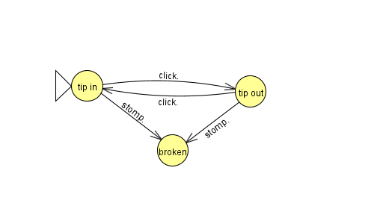

* The DFA is now an NFA because there is no stomp action that goes from tip in to tip out and vice versa.
* There was no issue with the input of click.click.click.stomp. but there was an issue with the input of click.click.click.stomp.click.. This is because there is no way to escape the broken state by using the click action.

**Part 2:**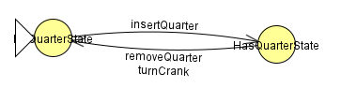

Gumball State Diagram requested:

**No**

**Part 3:**

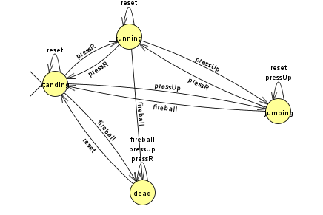

The four states are as follows: standing, running, jumping, and dead.

The three player actions are: pressR(to start or stop the character from running), pressUp(to have the player jump), and reset(only resets if the player is dead to restart the game).

The game action is a fireball that will hit the player and kill them if they are in the standing, or running states, bringing them to the dead state. It can only be exited using the reset player action. If the player is jumping, they will avoid the fireball and return them to the standing state.